**Baggage Information:**

This will help complete the below:

* Check baggage status
* Track current location
* Re-assign baggage
* Report missing

The sample data to be given as input is mentioned as Ex: in each input box.  This is applicable when a passenger is rebooked on another flight due to reasons like flight overbooked, passenger unfit etc.

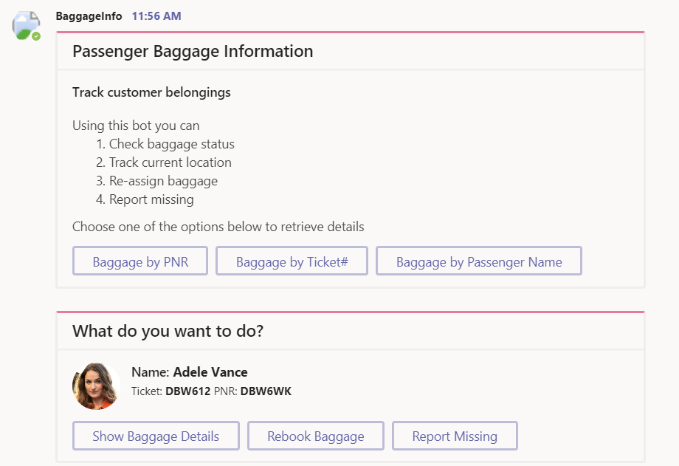

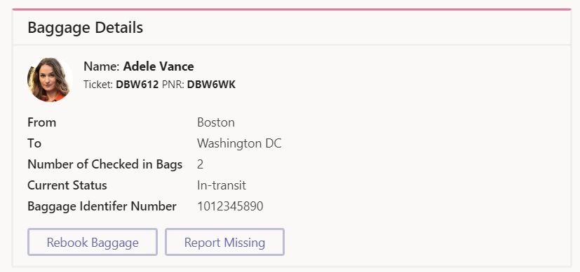

**Fleet Information:**

This is used to assign an aircraft to a flight. Gives a view of the fleet that the carrier owns and helps manage them.  You can assign an aircraft to the flight or mark as grounded for repair and maintenance. The sample data to be given as input is mentioned as Ex: in each input box.

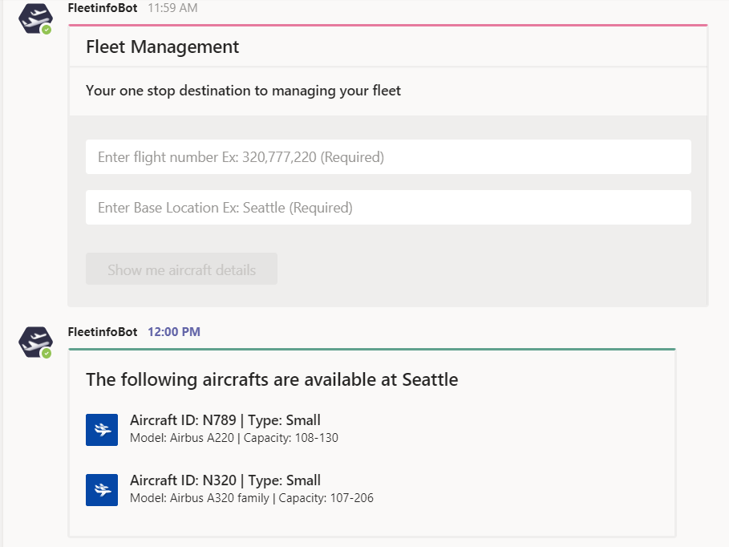

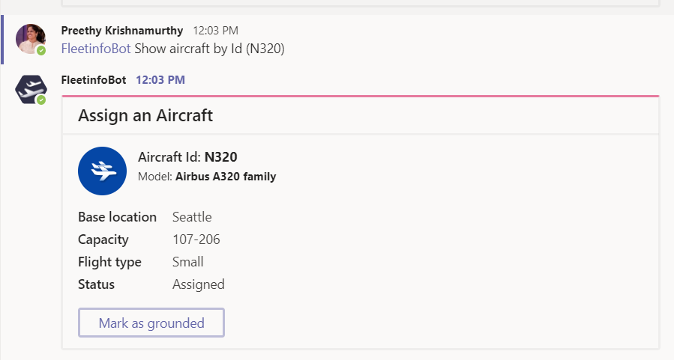

**Flight Information**:

This is used to get a glance of the flights between two locations across dates and also their availability. This can be used to rebook a passenger or in general to look up details of a particular flight. The sample data to be given as input is mentioned as Ex: in each input box.

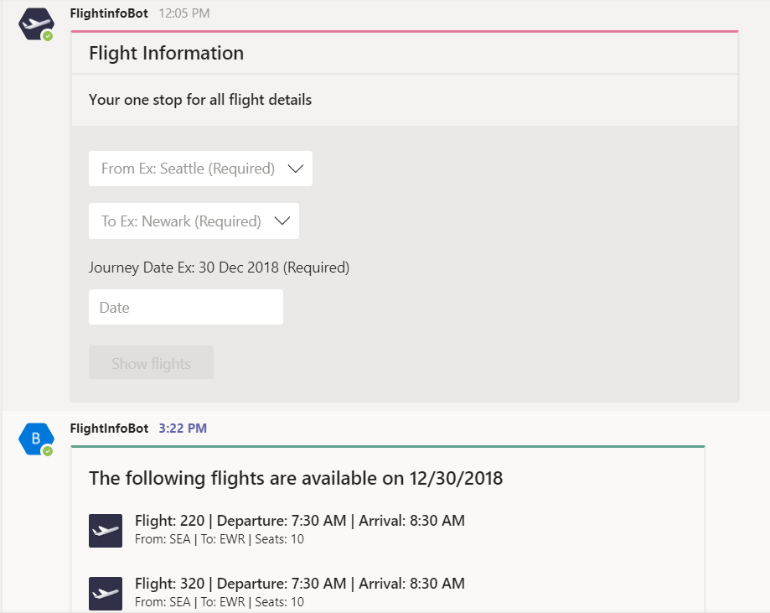

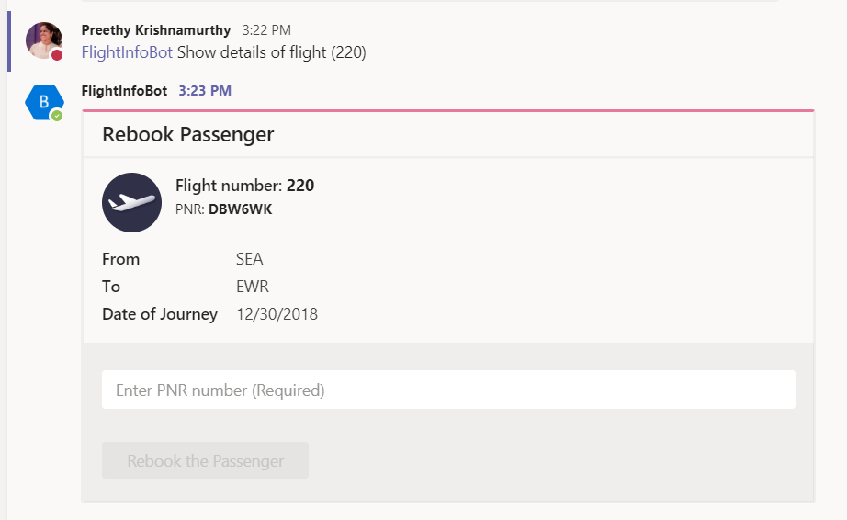

**Passenger Information:**

This has a bot and message extension to look up details about passengers on a flight. Has various scenarios to look up like those requiring special assistance, those with membership etc.

